**Multiple Choice**

1. Economics is the study of
   1. how much people should buy and the prices they should be willing to pay.
   2. how much people should sell and the prices they should be willing to accept.
   3. the allocation of the world's freely available resources and who should get them.
   4. the allocation and use of scarce resources to satisfy unlimited human wants.

Answer: D  
Learning Objective: 01-01

Topic: Economics and Opportunity Cost

Blooms: Remember

AACSB: Analytical Thinking

Difficulty: 1 Easy

1. The one word in the definition of economics that focuses on the fact that it is impossible to provide all of the goods and services that everyone wants is
   1. scarcity.
   2. resources.
   3. study.
   4. allocation.

Answer: A  
Learning Objective: 01-01  
Topic: Economics and Opportunity Cost

Blooms: Understand

AACSB: Analytical Thinking

Difficulty: 1 Easy

1. The one word in the definition of economics that focuses on the fact that we have to make choices about who gets what and how much is
   1. scarcity.
   2. resources.
   3. study.
   4. allocation.

Answer: D  
Learning Objective: 01-01  
Topic: Economics and Opportunity Cost

Blooms: Understand

AACSB: Analytical Thinking

Difficulty: 1 Easy

1. Economists focus on “unlimited human wants” rather than _____ to describe our pursuit of goods and services.
   1. needs
   2. prices
   3. output
   4. physical requirements

Answer: A  
Learning Objective: 01-01  
Topic: Economics and Opportunity Cost

Blooms: Understand

AACSB: Analytical Thinking

Difficulty: 1 Easy

1. Scarcity implies that the allocation scheme chosen by society can
   1. not make more of any one good.
   2. typically make more of a good but at the expense of making less of another.
   3. always make more of all goods simultaneously.

Answer: C  
Learning Objective: 01-01  
Topic: Economics and Opportunity Cost

Blooms: Understand

AACSB: Analytical Thinking

Difficulty: 1 Easy

1. Production possibilities frontier models
   1. the choices we make in setting prices.
   2. the choices we make in setting output alternatives.
   3. the choices we make in setting wages.
   4. the choices we make in setting incomes.

Answer: B

Learning Objective: 01-01  
Topic: Economics and Opportunity Cost

Blooms: Remember

AACSB: Analytical Thinking

Difficulty: 1 Easy

1. A production possibilities frontier is a simple model of
   1. scarcity and allocation.
   2. prices and output.
   3. production and costs.
   4. inputs and outputs.

Answer: A  
Learning Objective: 01-01  
Topic: Economics and Opportunity Cost

Blooms: Remember

AACSB: Analytical Thinking

Difficulty: 1 Easy

1. A simplifying assumption is typically made so as to
   1. make a point clearer by stripping away excess detail.
   2. make a point clearer by adding sufficient detail to get things precise.
   3. divert attention from the real problem.
   4. make things look better than they really are.

Answer: A  
Learning Objective: 01-01  
Topic: Economics and Opportunity Cost

Blooms: Understand

AACSB: Analytical Thinking

Difficulty: 1 Easy

1. Something is scarce as long as
   1. there is a price that the market puts on the item.
   2. there is no freely available infinite source of the item.
   3. the government provides it.
   4. the market provides it.

Answer: B  
Learning Objective: 01-01  
Topic: Economics and Opportunity Cost

Blooms: Understand

AACSB: Analytical Thinking

Difficulty: 1 Easy

1. A resource
   1. must come from the earth.
   2. only includes physical things.
   3. is anything that we consume directly or use to make things we will ultimately consume.
   4. A) and C)

Answer: C  
Learning Objective: 01-01  
Topic: Economics and Opportunity Cost

Blooms: Remember

AACSB: Analytical Thinking

Difficulty: 1 Easy

1. The underlying reason that there are unattainable points on a production possibilities frontier diagram is that there
   1. is government.
   2. are always choices that have to be made.
   3. is a scarcity of resources within a fixed level of technology.
   4. is unemployment of resources.

Answer: C  
Learning Objective: 01-01  
Topic: Modeling Opportunity Cost Using the Production Possibilities Frontier

Blooms: Apply

AACSB: Knowledge Application

Difficulty: 2 Medium

1. The underlying reason production possibilities frontiers are likely to be bowed out (rather than linear) is
   1. choices have consequences.
   2. there is always opportunity costs.
   3. some resources and people can be better used producing one good rather than another.
   4. there is always some level of unemployment.

Answer: C  
Learning Objective: 01-01  
Topic: Modeling Opportunity Cost Using the Production Possibilities Frontier

Blooms: Apply

AACSB: Knowledge Application

Difficulty: 2 Medium

1. The optimization assumption suggests that people make
   1. irrational decisions.
   2. unpredictable decisions.
   3. decisions to make themselves as well off as possible.
   4. decisions without thinking very hard.

Answer: C  
Learning Objective: 01-01  
Topic: Modeling Opportunity Cost Using the Production Possibilities Frontier

Blooms: Apply

AACSB: Knowledge Application

Difficulty: 2 Medium

1. The fact that we are operating at a point inside a bowed out production possibilities frontier, indicates there is
   1. scarcity.
   2. constant opportunity cost.
   3. unemployment.
   4. increasing opportunity cost.

Answer: C  
Learning Objective: 01-01  
Topic: Modeling Opportunity Cost Using the Production Possibilities Frontier

Blooms: Apply

AACSB: Knowledge Application

Difficulty: 2 Medium

1. If the production possibilities frontier is not bowed out but is a line, indicates there is
   1. scarcity.
   2. constant opportunity cost.
   3. unemployment.
   4. increasing opportunity cost.

Answer: B  
Learning Objective: 01-02  
Topic: Modeling Opportunity Cost Using the Production Possibilities Frontier

Blooms: Apply

AACSB: Knowledge Application

Difficulty: 2 Medium

1. The fact that the production possibilities frontier is bowed out indicates there is
   1. scarcity.
   2. constant opportunity cost.
   3. unemployment.
   4. increasing opportunity cost.

Answer: D  
Learning Objective: 01-02  
Topic: Modeling Opportunity Cost Using the Production Possibilities Frontier

Blooms: Apply

AACSB: Knowledge Application

Difficulty: 2 Medium

1. The fact that we cannot operate at a point outside a production possibilities frontier indicates there is
   1. scarcity.
   2. constant opportunity cost.
   3. unemployment.
   4. increasing opportunity cost.

Answer: A  
Learning Objective: 01-01  
Topic: Modeling Opportunity Cost Using the Production Possibilities Frontier

Blooms: Apply

AACSB: Knowledge Application

Difficulty: 2 Medium

1. Points on the Production Possibilities Frontier are
   1. attainable.
   2. unattainable.
   3. associated with some unemployment
   4. both attainable and unattainable.

Answer: A  
Learning Objective: 01-01  
Topic: Modeling Opportunity Cost Using the Production Possibilities Frontier

Blooms: Apply

AACSB: Knowledge Application

Difficulty: 2 Medium

1. Points inside the Production Possibilities Frontier are
   1. attainable.
   2. unattainable.
   3. associated with some unemployment.
   4. both attainable and unattainable.

Answer: D  
Learning Objective: 01-01  
Topic: Modeling Opportunity Cost Using the Production Possibilities Frontier

Blooms: Apply

AACSB: Knowledge Application

Difficulty: 2 Medium

1. Points outside the Production Possibilities Frontier are
   1. attainable.
   2. unattainable.
   3. associated with some unemployment.
   4. both attainable and unattainable.

Answer: B  
Learning Objective: 01-01  
Topic: Attributes of the Production Possibilities Frontier

Blooms: Apply

AACSB: Knowledge Application

Difficulty: 2 Medium

1. In Figure 1.1, which labeled points are attainable?

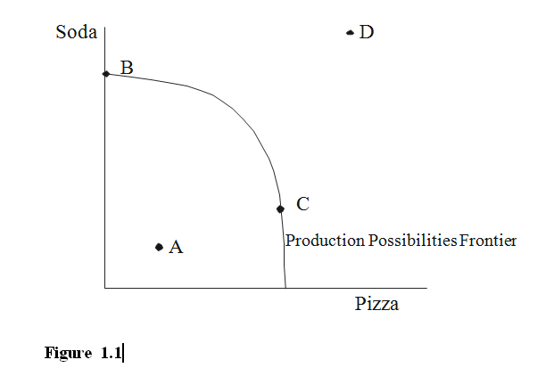

* 1. only A
  2. only B and C
  3. only D
  4. A, B and C

Answer: D  
Learning Objective: 01-01  
Topic: Attributes of the Production Possibilities Frontier

Blooms: Apply

AACSB: Knowledge Application

Difficulty: 2 Medium

1. In Figure 1.1, which labeled points are unattainable?



1. only A
2. only B and C
3. only D
4. A, B and C

Answer: C  
Learning Objective: 01-01  
Topic: Attributes of the Production Possibilities Frontier

Blooms: Apply

AACSB: Knowledge Application

Difficulty: 2 Medium

1. In Figure 1.1, which labeled points represent the existence of unemployment?



* 1. only A
  2. only B and C
  3. only D
  4. A, B and C

Answer: A  
Learning Objective: 01-01  
Topic: Attributes of the Production Possibilities Frontier

Blooms: Apply

AACSB: Knowledge Application

Difficulty: 2 Medium

1. In Figure 1.1, which labeled point indicates that there are sufficient resources and technology to produce the combination of goods represented by that point?



* 1. only A
  2. only B and C
  3. only D
  4. A, B and C

Answer: D  
Learning Objective: 01-01  
Topic: Attributes of the Production Possibilities Frontier

Blooms: Apply

AACSB: Knowledge Application

Difficulty: 2 Medium

1. In Figure 1.1, which labeled point indicates that there are insufficient resources or technology to produce the combination of goods represented by that point?



* 1. only A
  2. only B and C
  3. only D
  4. A, B and C

Answer: C  
Learning Objective: 01-01  
Topic: Attributes of the Production Possibilities Frontier

Blooms: Apply

AACSB: Knowledge Application

Difficulty: 2 Medium

1. In Figure 1.2, which labeled points are attainable?

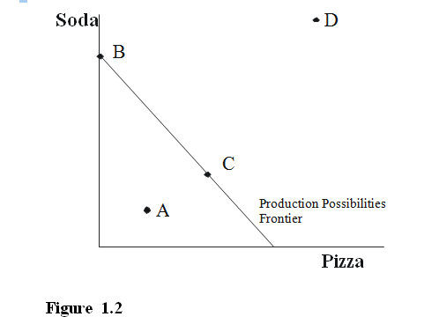

* 1. only A
  2. only B and C
  3. only D
  4. A, B and C

Answer: D  
Learning Objective: 01-01  
Topic: Attributes of the Production Possibilities Frontier

Blooms: Apply

AACSB: Knowledge Application

Difficulty: 2 Medium

1. In Figure 1.2, which labeled points are unattainable?



* 1. only A
  2. only B and C
  3. only D
  4. A, B and C

Answer: C  
Learning Objective: 01-01  
Topic: Attributes of the Production Possibilities Frontier

Blooms: Apply

AACSB: Knowledge Application

Difficulty: 2 Medium

1. In Figure 1.2, which labeled points represent the existence of unemployment?



* 1. only A
  2. only B and C
  3. only D
  4. A, B and C

Answer: A  
Learning Objective: 01-01  
Topic: Attributes of the Production Possibilities Frontier

Blooms: Apply

AACSB: Knowledge Application

Difficulty: 2 Medium

1. In Figure 1.2, which labeled point indicates that there are sufficient resources and technology to produce the combination of goods represented by that point?



* 1. only A
  2. only C
  3. only D
  4. A, B and C

Answer: D  
Learning Objective: 01-01  
Topic: Attributes of the Production Possibilities Frontier

Blooms: Apply

AACSB: Knowledge Application

Difficulty: 2 Medium

1. In Figure 1.2, which labeled point indicates that there are insufficient resources or technology to produce the combination of goods represented by that point?



* 1. only A
  2. only C
  3. only D
  4. A, B and C

Answer: C  
Learning Objective: 01-01  
Topic: Attributes of the Production Possibilities Frontier

Blooms: Apply

AACSB: Knowledge Application

Difficulty: 2 Medium

1. In Figure 1.3 A, B and C, which depicts the existence of opportunity cost?

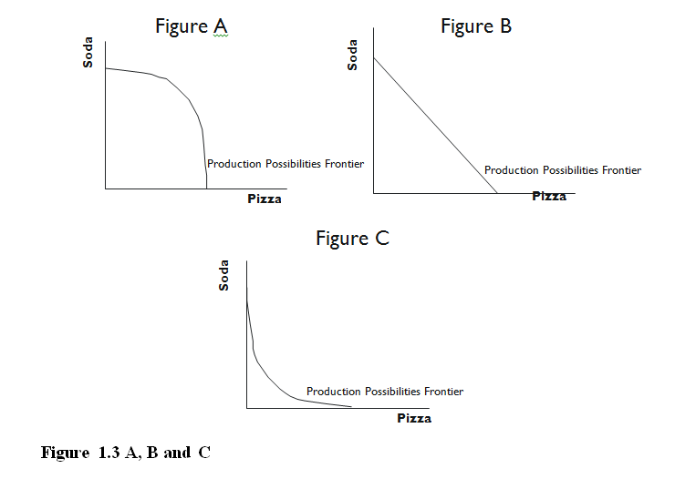

* 1. Figure A
  2. Figure B
  3. Figure C
  4. All three figures show the existence of opportunity cost.

Answer: D  
Learning Objective: 01-01  
Topic: Modeling Opportunity Cost Using the Production Possibilities Frontier

Blooms: Apply

AACSB: Knowledge Application

Difficulty: 2 Medium

1. In Figure 1.3 A, B and C, which depicts the existence of scarcity?



* 1. Figure A
  2. Figure B
  3. Figure C
  4. All three figures show the existence of scarcity.

Answer: D  
Learning Objective: 01-01  
Topic: Attributes of the Production Possibilities Frontier

Blooms: Apply

AACSB: Knowledge Application

Difficulty: 2 Medium

1. In Figure 1.3 A, B and C, which depicts the existence of constant opportunity cost?



* 1. Figure A
  2. Figure B
  3. Figure C
  4. All three figures show the existence of constant opportunity cost.

Answer: B  
Learning Objective: 01-02  
Topic: Attributes of the Production Possibilities Frontier

Blooms: Apply

AACSB: Knowledge Application

Difficulty: 2 Medium

1. In Figure 1.3 A, B and C, which depicts the existence of increasing opportunity cost?



* 1. Figure A
  2. Figure B
  3. Figure C
  4. All three figures show the existence of increasing opportunity cost.

Answer: A  
Learning Objective: 01-02  
Topic: Attributes of the Production Possibilities Frontier

Blooms: Apply

AACSB: Knowledge Application

Difficulty: 2 Medium

1. Using Figure 1.4 you can tell that

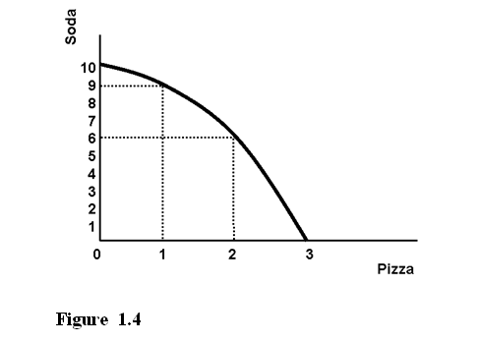

* 1. there is increasing opportunity cost.
  2. there is unemployment.
  3. there is constant opportunity cost.
  4. the technology does not exist to produce 9 units of soda and 1 unit of pizza.

Answer: A  
Learning Objective: 01-02  
Topic: Attributes of the Production Possibilities Frontier

Blooms: Apply

AACSB: Knowledge Application

Difficulty: 2 Medium

1. Using Figure 1.4 you can tell that



* 1. the technology does not exist to produce 6 units of soda and 2 unit of pizza.
  2. there is unemployment.
  3. there is constant opportunity cost.
  4. the technology does not exist to produce 9 units of soda and 3 unit of pizza.

Answer: D  
Learning Objective: 01-02  
Topic: Attributes of the Production Possibilities Frontier

Blooms: Apply

AACSB: Knowledge Application

Difficulty: 2 Medium

1. Using Figure 1.4 we know the production of 6 units of soda and 2 units of pizza is



* 1. possible, but there would be unemployment.
  2. possible, but only if all resources were fully employed.
  3. impossible because we have the resources but do not have the technology.
  4. impossible because we have the technology but do not have the resources.

Answer: B  
Learning Objective: 01-02  
Topic: Attributes of the Production Possibilities Frontier

Blooms: Evaluate

AACSB: Analytical Thinking

Difficulty: 3 Hard

1. Using Figure 1.4 we know the production of 9 units of soda and 1 units of pizza is



* 1. possible, but there would be unemployment.
  2. possible, but only if all resources were fully employed.
  3. impossible because we have the resources but do not have the technology.
  4. impossible because we have the technology but do not have the resources.

Answer: B  
Learning Objective: 01-02  
Topic: Attributes of the Production Possibilities Frontier

Blooms: Evaluate

AACSB: Analytical Thinking

Difficulty: 3 Hard

1. Using Figure 1.4 above we know the production of 9 units of soda and 3 units of pizza is



* 1. possible, but there would be unemployment.
  2. possible, but only if all resources were fully employed.
  3. impossible because we either do not have the resources or the technology.
  4. undesirable.

Answer: C  
Learning Objective: 01-02  
Topic: Attributes of the Production Possibilities Frontier

Blooms: Evaluate

AACSB: Analytical Thinking

Difficulty: 3 Hard

1. Using Figure 1.4 above we know the production of 4 units of soda and 2 units of pizza is



* 1. possible, but there would be unemployed resources.
  2. possible, but only if all resources were fully employed.
  3. impossible because we have the resources but do not have the technology.
  4. impossible because we have the technology but do not have the resources.

Answer: A  
Learning Objective: 01-02  
Topic: Attributes of the Production Possibilities Frontier

Blooms: Evaluate

AACSB: Analytical Thinking

Difficulty: 3 Hard

1. Referring to Figure 1.4, the opportunity cost of producing the first unit of pizza is



* 1. one unit of soda.
  2. three units of soda.
  3. six units of soda.
  4. the same as the opportunity cost of producing the second unit of pizza.

Answer: A  
Learning Objective: 01-02  
Topic: Attributes of the Production Possibilities Frontier

Blooms: Evaluate

AACSB: Analytical Thinking

Difficulty: 3 Hard

1. Referring to Figure 1.4, the opportunity cost of producing the second unit of pizza is



* 1. one unit of soda.
  2. three units of soda.
  3. six units of soda.
  4. the same as the opportunity cost of producing the first unit of pizza.

Answer: B  
Learning Objective: 01-02  
Topic: Attributes of the Production Possibilities Frontier

Blooms: Evaluate

AACSB: Analytical Thinking

Difficulty: 3 Hard

1. Referring to Figure 1.4, the opportunity cost of producing the third unit of pizza is



* 1. one unit of soda.
  2. three units of soda.
  3. six units of soda.
  4. the same as the opportunity cost of producing the first unit of pizza.

Answer: D  
Learning Objective: 01-02  
Topic: Attributes of the Production Possibilities Frontier

Blooms: Evaluate

AACSB: Analytical Thinking

Difficulty: 3 Hard

1. Using Figure 1.5 above you can tell that

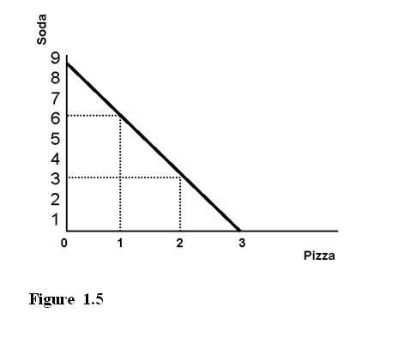

* 1. there is increasing opportunity cost.
  2. there is unemployment.
  3. there is constant opportunity cost.
  4. the technology does not exist to produce 6 units of soda and 1 unit of pizza.

Answer: C  
Learning Objective: 01-02  
Topic: Attributes of the Production Possibilities Frontier

Blooms: Evaluate

AACSB: Analytical Thinking

Difficulty: 3 Hard

1. Using Figure 1.5 above you can tell that



* 1. the technology does not exist to produce 4 units of soda and 1 unit of pizza.
  2. there is unemployment.
  3. there is increasing opportunity cost.
  4. the technology does not exist to produce 3 units of soda and 3 unit of pizza.

Answer: D  
Learning Objective: 01-02  
Topic: Attributes of the Production Possibilities Frontier

Blooms: Evaluate

AACSB: Analytical Thinking

Difficulty: 3 Hard

1. Using Figure 1.5 above we know the production of 3 units of soda and 2 units of pizza is



* 1. possible, but there would be unemployed.
  2. possible, but only if all resources were fully employed.
  3. impossible because we have the resources but do not have the technology.
  4. impossible because we have the technology but do not have the resources.

Answer: B  
Learning Objective: 01-02  
Topic: Attributes of the Production Possibilities Frontier

Blooms: Evaluate

AACSB: Analytical Thinking

Difficulty: 3 Hard

1. Using Figure 1.5 above we know the production of 6 units of soda and 1 unit of pizza is



* 1. possible, but there would be unemployed resources.
  2. possible, but only if all resources were fully employed.
  3. impossible because we have the resources but do not have the technology.
  4. impossible because we have the technology but do not have the resources.

Answer: B  
Learning Objective: 01-02  
Topic: Attributes of the Production Possibilities Frontier

Blooms: Evaluate

AACSB: Analytical Thinking

Difficulty: 3 Hard

1. Using Figure 1.5 above we know the production of 6 units of soda and 2 units of pizza is



* 1. possible, but there would be unemployed resources.
  2. possible, but only if all resources were fully employed.
  3. impossible because we either do not have the resources or the technology.
  4. undesirable.

Answer: C  
Learning Objective: 01-02  
Topic: Attributes of the Production Possibilities Frontier

Blooms: Evaluate

AACSB: Analytical Thinking

Difficulty: 3 Hard

1. Using Figure 1.5 above we know the production of 2 units of soda and 2 units of pizza is



* 1. possible, but there would be unemployed resources.
  2. possible, but only if all resources were fully employed.
  3. impossible because we have the resources but do not have the technology.
  4. impossible because we have the technology but do not have the resources.

Answer: A  
Learning Objective: 01-02  
Topic: Attributes of the Production Possibilities Frontier

Blooms: Evaluate

AACSB: Analytical Thinking

Difficulty: 3 Hard

1. Referring to Figure 1.5, the opportunity cost of producing the first unit of pizza is



* 1. one unit of soda.
  2. three units of soda.
  3. six units of soda.

Answer: B  
Learning Objective: 01-02  
Topic: Attributes of the Production Possibilities Frontier

Blooms: Evaluate

AACSB: Analytical Thinking

Difficulty: 3 Hard

1. Referring to Figure 1.5, the opportunity cost of producing the second unit of pizza is



* 1. one unit of soda.
  2. three units of soda.
  3. six units of soda.

Answer: B  
Learning Objective: 01-02  
Topic: Attributes of the Production Possibilities Frontier

Blooms: Evaluate

AACSB: Analytical Thinking

Difficulty: 3 Hard

1. Referring to Figure 1.5, the opportunity cost of producing the third unit of pizza is



* 1. one unit of soda.
  2. three units of soda.
  3. six units of soda.

Answer: B  
Learning Objective: 01-02  
Topic: Attributes of the Production Possibilities Frontier

Blooms: Evaluate

AACSB: Analytical Thinking

Difficulty: 3 Hard

1. Using Figure 1.6 you can tell that

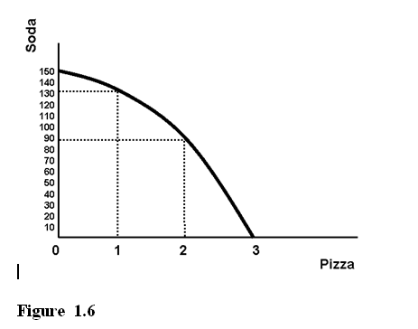

* 1. there is increasing opportunity cost.
  2. there is unemployment.
  3. there is constant opportunity cost.
  4. the technology does not exist to produce 90 units of soda and 2 units of pizza.

Answer: A  
Learning Objective: 01-02  
Topic: Attributes of the Production Possibilities Frontier

Blooms: Apply

AACSB: Knowledge Application

Difficulty: 2 Medium

1. Using Figure 1.6 you can tell that



* 1. the technology does not exist to produce 130 units of soda and 1 unit of pizza.
  2. there is unemployment.
  3. there is constant opportunity cost.
  4. the technology does not exist to produce 90 units of soda and 3 units of pizza.

Answer: D  
Learning Objective: 01-02  
Topic: Attributes of the Production Possibilities Frontier

Blooms: Apply

AACSB: Knowledge Application

Difficulty: 2 Medium

1. Using Figure 1.6 we know the production of 90 units of soda and 2 units of pizza is



* 1. possible, but there would be unemployed resources.
  2. possible, but only if all resources were fully employed.
  3. impossible because we have the resources but do not have the technology.
  4. impossible because we have the technology but do not have the resources.

Answer: B  
Learning Objective: 01-02  
Topic: Attributes of the Production Possibilities Frontier

Blooms: Evaluate

AACSB: Analytical Thinking

Difficulty: 3 Hard

1. Using Figure 1.6 we know the production of 130 units of soda and 1 unit of pizza is



* 1. possible, but there would be unemployed resources.
  2. possible, but only if all resources were fully employed.
  3. impossible because we have the resources but do not have the technology.
  4. impossible because we have the technology but do not have the resources.

Answer: B  
Learning Objective: 01-02  
Topic: Attributes of the Production Possibilities Frontier

Blooms: Evaluate

AACSB: Analytical Thinking

Difficulty: 3 Hard

1. Using Figure 1.6 we know the production of 90 units of soda and 4 units of pizza is



* 1. possible, but there would be unemployed resources.
  2. possible, but only if all resources were fully employed.
  3. impossible because we either do not have the resources or the technology.
  4. undesirable.

Answer: C  
Learning Objective: 01-02  
Topic: Attributes of the Production Possibilities Frontier

Blooms: Evaluate

AACSB: Analytical Thinking

Difficulty: 3 Hard

1. Using Figure 1.6 we know the production of 90 units of soda and 1 units of pizza is



* 1. possible, but there would be unemployed resources.
  2. possible, but only if all resources were fully employed.
  3. impossible because we have the resources but do not have the technology.
  4. impossible because we have the technology but do not have the resources.

Answer: A  
Learning Objective: 01-02  
Topic: Attributes of the Production Possibilities Frontier

Blooms: Evaluate

AACSB: Analytical Thinking

Difficulty: 3 Hard

1. Using Figure 1.7 you can tell that

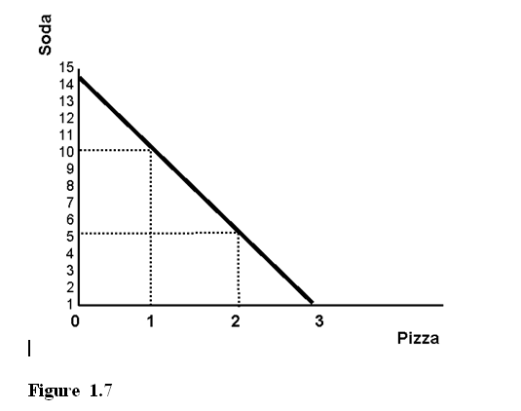

* 1. there is increasing opportunity cost.
  2. there is unemployment.
  3. there is constant opportunity cost.
  4. the technology does not exist to produce 10 units of soda and 1 unit of pizza.

Answer: C  
Learning Objective: 01-02  
Topic: Attributes of the Production Possibilities Frontier

Blooms: Evaluate

AACSB: Analytical Thinking

Difficulty: 3 Hard

1. Using Figure 1.7 you can tell that



* 1. the technology does not exist to produce 5 units of soda and 3 units of pizza.
  2. there is unemployment.
  3. there is increasing opportunity cost.
  4. the technology does not exist to produce 10 units of soda and 1 units of pizza.

Answer: A  
Learning Objective: 01-02  
Topic: Attributes of the Production Possibilities Frontier

Blooms: Evaluate

AACSB: Analytical Thinking

Difficulty: 3 Hard

Refer to: Figure 1.7

1. Using Figure 1.7 we know the production of 5 units of soda and 2 units of pizza is



* 1. possible, but there would be unemployed resources.
  2. possible, but only if all resources were fully employed.
  3. impossible because we have the resources but do not have the technology.
  4. impossible because we have the technology but do not have the resources.

Answer: B  
Learning Objective: 01-02  
Topic: Attributes of the Production Possibilities Frontier

Blooms: Evaluate

AACSB: Analytical Thinking

Difficulty: 3 Hard

1. Using Figure 1.7 we know the production of 10 units of soda and 1 unit of pizza is



* 1. possible, but there would be unemployed resources.
  2. possible, but only if all resources were fully employed.
  3. impossible because we have the resources but do not have the technology.
  4. impossible because we have the technology but do not have the resources.

Answer: B  
Learning Objective: 01-02  
Topic: Attributes of the Production Possibilities Frontier

Blooms: Evaluate

AACSB: Analytical Thinking

Difficulty: 3 Hard

1. Using Figure 1.7 we know the production of 10 units of soda and 2 units of pizza is



* 1. possible, but there would be unemployed resources.
  2. possible, but only if all resources were fully employed.
  3. impossible because we either do not have the resources or the technology.
  4. undesirable.

Answer: C  
Learning Objective: 01-02  
Topic: Attributes of the Production Possibilities Frontier

Blooms: Evaluate

AACSB: Analytical Thinking

Difficulty: 3 Hard

1. Using Figure 1.7 we know the production of 4 units of soda and 2 units of pizza is



* 1. possible, but there would be unemployed resources.
  2. possible, but only if all resources were fully employed.
  3. impossible because we have the resources but do not have the technology.
  4. impossible because we have the technology but do not have the resources.

Answer: A  
Learning Objective: 01-02  
Topic: Attributes of the Production Possibilities Frontier

Blooms: Evaluate

AACSB: Analytical Thinking

Difficulty: 3 Hard

1. Referring to Figure 1.8, if a point is attainable it is in

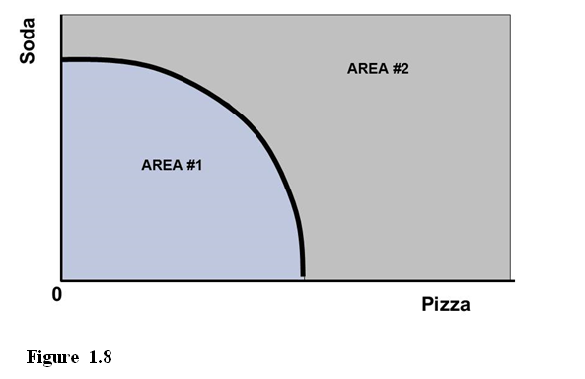

* 1. AREA #1 but not on the curve.
  2. AREA #1 or is on the curve.
  3. AREA #2 but not on the curve.
  4. AREA #2 or is on the curve.

Answer: B  
Learning Objective: 01-01  
Topic: Attributes of the Production Possibilities Frontier

Blooms: Apply

AACSB: Knowledge Application

Difficulty: 2 Medium

1. Referring to Figure 1.8, if a point is unattainable it is in



* 1. AREA #1 but not on the curve.
  2. AREA #1 or is on the curve.
  3. AREA #2 but not on the curve.
  4. AREA #2 or is on the curve.

Answer: C  
Learning Objective: 01-01  
Topic: Attributes of the Production Possibilities Frontier

Blooms: Apply

AACSB: Knowledge Application

Difficulty: 2 Medium

1. Referring to Figure 1.8, if a point represents unemployment it is in



* 1. AREA #1 but not on the curve.
  2. AREA #1 or is on the curve.
  3. AREA #2 but not on the curve.
  4. AREA #2 or is on the curve.

Answer: A  
Learning Objective: 01-01  
Topic: Attributes of the Production Possibilities Frontier

Blooms: Apply

AACSB: Knowledge Application

Difficulty: 2 Medium

1. Referring to Figure 1.9, if a point is attainable it is in

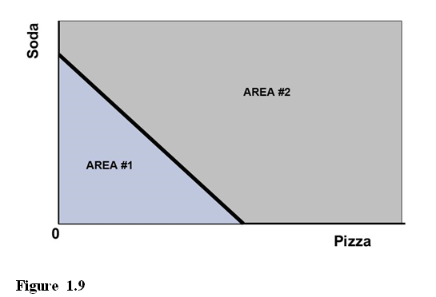

* 1. AREA #1 but not on the curve.
  2. AREA #1 or is on the curve.
  3. AREA #2 but not on the curve.
  4. AREA #2 or is on the curve.

Answer: B  
Learning Objective: 01-01  
Topic: Attributes of the Production Possibilities Frontier

Blooms: Apply

AACSB: Knowledge Application

Difficulty: 2 Medium

1. Referring to Figure 1.9, if a point is unattainable it is in



* 1. AREA #1 but not on the curve.
  2. AREA #1 or is on the curve.
  3. AREA #2 but not on the curve.
  4. AREA #2 or is on the curve.

Answer: C  
Learning Objective: 01-01  
Topic: Attributes of the Production Possibilities Frontier

Blooms: Apply

AACSB: Knowledge Application

Difficulty: 2 Medium

1. Referring to Figure 1.9, if a point represents unemployment it is in



* 1. AREA #1 but not on the curve.
  2. AREA #1 or is on the curve.
  3. AREA #2 but not on the curve.
  4. AREA #2 or is on the curve.

Answer: A  
Learning Objective: 01-01  
Topic: Attributes of the Production Possibilities Frontier

Blooms: Apply

AACSB: Knowledge Application

Difficulty: 2 Medium

1. Chapter 1 entitled "Economics: The Study of Opportunity Cost" makes the point that we
   1. can produce all we want of everything we want if we just work harder.
   2. face tradeoffs because we have limited resources.
   3. can avoid tradeoffs if we simply make the right decisions.
   4. do not face tradeoffs because we have limited resources.

Answer: B  
Learning Objective: 01-01  
Topic: Modeling Opportunity Cost Using the Production Possibilities Frontier

Blooms: Apply

AACSB: Knowledge Application

Difficulty: 1 Easy

1. Imagine an economist ordering pizza by the slice. When deciding how many slices to order she would pick that number where the enjoyment of the _____ equals the enjoyment she could get from using the money on another good.
   1. first slice
   2. last slice
   3. average slice
   4. total number of slices

Answer: B  
Learning Objective: 01-03  
Topic: Thinking Economically

Blooms: Apply

AACSB: Knowledge Application

Difficulty: 2 Medium

1. An economist, when analyzing a problem will compare the ___ and choose the outcome where they are equal
   1. average benefits to the average costs
   2. marginal benefits to the marginal costs
   3. total benefits to the total costs
   4. fixed benefits to the fixed costs

Answer: B  
Learning Objective: 01-03  
Topic: Thinking Economically

Blooms: Apply

AACSB: Knowledge Application

Difficulty: 2 Medium

1. An economist, when analyzing a problem will attempt to
   1. maximize the net benefit of an action and this occurs where the marginal benefit equals the marginal cost.
   2. maximize the total benefit of an action.
   3. minimize the total cost of an action.
   4. maximize the net benefit of an action and this occurs where the average benefit equals the average cost.

Answer: A  
Learning Objective: 01-03  
Topic: Thinking Economically

Blooms: Understand

AACSB: Analytical Thinking

Difficulty: 1 Easy

1. Economic incentives can come from
   1. markets.
   2. government programs.
   3. taxes.
   4. all of the options are correct.

Answer: D  
Learning Objective: 01-03

Topic: Thinking Economically

Blooms: Understand

AACSB: Analytical Thinking

Difficulty: 1 Easy

1. The statement that "since a farmer will make more money if he has a bumper crop means that all farmers would make more money if they all had bumper crops" would be an example of which of the following?
   1. the fallacy that correlation is the same as causation
   2. the fallacy of composition
   3. truth in an obvious form
   4. A) and B)

Answer: B  
Learning Objective: 01-03

Topic: Thinking Economically

Blooms: Apply

AACSB: Knowledge Application

Difficulty: 2 Medium

1. Logging companies are always more profitable if they are able to harvest more (rather than less) lumber in a month. If you concluded from that fact that the logging industry is more profitable if all of the firms in the industry harvest more, then you would be
   1. right.
   2. wrong because causation and correlation are not the same.
   3. wrong and have fallen victim to the fallacy of composition.
   4. wrong because firms operate on jealousy.

Answer: C  
Learning Objective: 01-03

Topic: Thinking Economically

Blooms: Apply

AACSB: Knowledge Application

Difficulty: 2 Medium

1. Every worker is better off making more money and having better benefits. If you concluded from that fact that all workers would be better off if a law were passed requiring a 25% increase in wages and benefits, then you would be
   1. right.
   2. wrong because causation and correlation are not the same.
   3. wrong and have fallen victim to the fallacy of composition.
   4. wrong because workers operate on jealousy.

Answer: C  
Learning Objective: 01-03

Topic: Thinking Economically

Blooms: Apply

AACSB: Knowledge Application

Difficulty: 2 Medium

1. Many forms of seafood (lobster, crab legs etc.) are consumed by dipping the meat in melted garlic butter. If someone suggested that it would therefore be equally appealing to drink melted butter after having eaten garlic and unseasoned seafood, you would know they had fallen victim to which of the following?
   1. the fallacy that correlation is the same as causation
   2. the fallacy of composition
   3. a logical tautology
   4. none of the options are correct

Answer: B  
Learning Objective: 01-03

Topic: Thinking Economically

Blooms: Apply

AACSB: Knowledge Application

Difficulty: 2 Medium

1. Of course, all individual students are better off if they get better grades. If you were to conclude that all students would be better off if everyone received an “A” you would
   1. have fallen victim to the fallacy of scarcity.
   2. be right.
   3. have fallen victim to the fallacy of composition.
   4. be mistaking correlation with causation.

Answer: C  
Learning Objective: 01-03

Topic: Thinking Economically

Blooms: Apply

AACSB: Knowledge Application

Difficulty: 2 Medium

1. The fact that snow cones sales fall when snow accumulated from the sky suggests that snow cones sales and snow on the ground are
   1. directly correlated.
   2. inversely correlated.
   3. neither directly correlated nor inversely correlated.
   4. both directly correlated and inversely correlated.

Answer: B  
Learning Objective: 01-03

Topic: Thinking Economically

Blooms: Apply

AACSB: Knowledge Application

Difficulty: 2 Medium

1. If you were to conclude, after carefully examining data and using proper evaluation techniques, that a tax credit for attending college benefits the poor more than a tax deduction (of equal total cost to the government) would, you would have engaged in _________ analysis to reach that conclusion.
   1. contra-indicative
   2. positive
   3. normative
   4. creative

Answer: B  
Learning Objective: 01-03

Topic: Thinking Economically

Blooms: Apply

AACSB: Knowledge Application

Difficulty: 2 Medium

1. When analyzing a problem, if an economist is attempting to understand why something happened without considering whether or not the action was fair or just, the economist is thinking
   1. positively.
   2. negatively.
   3. normatively.
   4. justifiably.

Answer: A  
Learning Objective: 01-03

Topic: Thinking Economically

Blooms: Apply

AACSB: Knowledge Application

Difficulty: 2 Medium

1. When analyzing a problem, if an economist is attempting to understand what caused something to happen without considering whether or not the action was fair or just, the economist is thinking
   1. positively.
   2. negatively.
   3. normatively.
   4. justifiably.

Answer: A  
Learning Objective: 01-03

Topic: Thinking Economically

Blooms: Apply

AACSB: Knowledge Application

Difficulty: 2 Medium

1. When analyzing a problem, if an economist is attempting to understand whether or not an action was fair or just, the economist is thinking
   1. positively.
   2. negatively.
   3. normatively.
   4. justifiably.

Answer: C  
Learning Objective: 01-03

Topic: Thinking Economically

Blooms: Understand

AACSB: Ethics

Difficulty: 1 Easy

1. When analyzing a problem, if an economist is attempting to understand what the future implications of an action are without considering whether or not the action was fair or just, the economist is thinking
   1. positively.
   2. negatively.
   3. normatively.
   4. justifiably.

Answer: A  
Learning Objective: 01-03

Topic: Thinking Economically

Blooms: Understand

AACSB: Ethics

Difficulty: 1 Easy

1. Some suggest that when economists claim to be thinking ________, they are _____.
   1. normatively; deluding themselves
   2. positively; deluding themselves
   3. normatively; really thinking positively
   4. negatively; deluding themselves

Answer: B  
Learning Objective: 01-03

Topic: Thinking Economically

Blooms: Understand

AACSB: Ethics

Difficulty: 1 Easy

1. The fact that when the temperature rises snow shovel sales fall suggests the two are
   1. directly correlated.
   2. inversely correlated.
   3. neither directly correlated nor inversely correlated.
   4. both directly correlated and inversely correlated.

Answer: B  
Learning Objective: 01-03

Topic: Thinking Economically

Blooms: Evaluate

AACSB: Analytical Thinking

Difficulty: 3 Hard

1. The fact that when temperature rises snow cone sales rise suggests the two are
   1. directly correlated.
   2. inversely correlated.
   3. neither directly correlated nor inversely correlated.
   4. both directly correlated and inversely correlated.

Answer: A  
Learning Objective: 01-03

Topic: Thinking Economically

Blooms: Evaluate

AACSB: Analytical Thinking

Difficulty: 3 Hard

1. The fact that as snow accumulates, snow shovel sales rise suggests the two are
   1. directly correlated.
   2. inversely correlated.
   3. neither directly correlated nor inversely correlated.
   4. both directly correlated and inversely correlated.

Answer: A  
Learning Objective: 01-03

Topic: Thinking Economically

Blooms: Evaluate

AACSB: Analytical Thinking

Difficulty: 3 Hard

1. The statement that Congress passed a tax bill and two months later a recession began, so the bill must have been poor policy is an example of
   1. the fallacy that correlation is the same as causation.
   2. the fallacy of composition.
   3. truth in an obvious form.
   4. both A) and B)

Answer: A  
Learning Objective: 01-03

Topic: Thinking Economically

Blooms: Evaluate

AACSB: Analytical Thinking

Difficulty: 3 Hard

1. The statement that Congress passed a tax bill and two months later a recession ended, so the bill must have been good policy is an example of
   1. the fallacy that correlation is the same as causation.
   2. the fallacy of composition.
   3. truth in an obvious form.
   4. both A) and B)

Answer: A  
Learning Objective: 01-03

Topic: Thinking Economically

Blooms: Evaluate

AACSB: Analytical Thinking

Difficulty: 3 Hard

1. If you concluded from the fact that the last three recessions have occurred while Republicans were President that their fiscal policies create recessions then you would be
   1. right.
   2. wrong because causation and correlation are not the same.
   3. wrong and have fallen victim to the fallacy of composition.
   4. wrong because Democrats are much worse.

Answer: B  
Learning Objective: 01-03

Topic: Thinking Economically

Blooms: Evaluate

AACSB: Analytical Thinking

Difficulty: 3 Hard

1. An example of an incentive designed to promote savings would be
   1. a tax provision that reduces the effective interest rate garnered by savings.
   2. an increase in the sales tax.
   3. an increase in the capital gains tax rate.
   4. a decrease in the exclusion from taxable income of the first $100 of dividends.

Answer: D  
Learning Objective: 01-03

Topic: Thinking Economically

Blooms: Evaluate

AACSB: Analytical Thinking

Difficulty: 3 Hard

1. Each person is better off with a bigger tax return than with a small tax return. That means that everyone would be better off if all taxes were zero. A person saying that is
   1. right.
   2. wrong because causation and correlation are not the same.
   3. wrong and have fallen victim to the fallacy of composition.
   4. wrong because firms operate on jealousy.

Answer: C  
Learning Objective: 01-03

Topic: Thinking Economically

Blooms: Evaluate

AACSB: Analytical Thinking

Difficulty: 3 Hard

1. Suppose you heard a person speaking about two graphs. You couldn’t make out quite what they were saying but you saw that since 1920, the variable on the left graph showed a decreasing value and the variable on the right graph showed an increasing value. If they asserted that the left graph variable’s decrease therefore caused the right variable’s increase you would be
   1. convinced of the soundness of their argument.
   2. not yet convinced because you understand that causation and correlation are not the same.
   3. not yet convinced because you understand the fallacy of composition.
   4. correctly convinced that they were wrong.

Answer: B  
Learning Objective: 01-03

Topic: Thinking Economically

Blooms: Evaluate

AACSB: Analytical Thinking

Difficulty: 3 Hard

1. Every worker is better off making more money and having better benefits. If you concluded from that fact that all workers would be better off if a law were passed requiring a 25% increase in wages and benefits then you would be
   1. right.
   2. wrong because causation and correlation are not the same.
   3. wrong and have fallen victim to the fallacy of composition.
   4. wrong because workers operate on jealousy.

Answer: C  
Learning Objective: 01-03

Topic: Thinking Economically

Blooms: Evaluate

AACSB: Analytical Thinking

Difficulty: 3 Hard

1. Logging companies are always more profitable if they are able to harvest more (rather than less) lumber in a month. If you concluded from that fact that the logging industry is more profitable if all of the firms in the industry harvest more then you would be
   1. right.
   2. wrong because causation and correlation are not the same.
   3. wrong and have fallen victim to the fallacy of composition.
   4. wrong because firms operate on jealousy.

Answer: C  
Learning Objective: 01-03

Topic: Thinking Economically

Blooms: Evaluate

AACSB: Analytical Thinking

Difficulty: 3 Hard

1. If you concluded from the fact that the last three recessions have occurred while Republicans were President that their fiscal policies create recessions then you would be
   1. right.
   2. wrong because causation and correlation are not the same.
   3. wrong and have fallen victim to the fallacy of composition.
   4. wrong because Democrats are much worse.

Answer: B  
Learning Objective: 01-03

Topic: Thinking Economically

Blooms: Evaluate

AACSB: Analytical Thinking

Difficulty: 3 Hard

1. The statement that “since a farmer will make more money if he has a bumper crop means that all farmers would make more money if they all had bumper crops” would be an example of which of the following?
   1. the fallacy that correlation is the same as causation
   2. the fallacy of composition
   3. truth in an obvious form
   4. none of the options are correct

Answer: B  
Learning Objective: 01-03

Topic: Thinking Economically

Blooms: Evaluate

AACSB: Analytical Thinking

Difficulty: 3 Hard

1. Any mechanism by which buyers and sellers negotiate an exchange is a
   1. corporation.
   2. market.
   3. negotiable instrument.
   4. brokerage.

Answer: B  
Learning Objective: 01-03

Topic: The Big Picture

Blooms: Understand

AACSB: Analytical Thinking

Difficulty: 1 Easy

1. A mechanism by which buyers and sellers of labor and financial capital negotiate an exchange is a
   1. stock market.
   2. bond market.
   3. factor market.
   4. brokerage.

Answer: C  
Learning Objective: 01-03

Topic: The Big Picture

Blooms: Understand

AACSB: Analytical Thinking

Difficulty: 1 Easy

1. A mechanism by which buyers and sellers of goods and services negotiate an exchange is a
   1. goods and services market.
   2. goods and services convention.
   3. goods and services union.
   4. factor market.

Answer: A  
Learning Objective: 01-03

Topic: The Big Picture

Blooms: Understand

AACSB: Analytical Thinking

Difficulty: 1 Easy

1. A mechanism by which buyers and sellers of the currencies of the various countries negotiate an exchange is a
   1. foreign bank.
   2. foreign stock market.
   3. foreign exchange market.
   4. foreign currency reserve.

Answer: C  
Learning Objective: 01-03

Topic: The Big Picture

Blooms: Understand

AACSB: Analytical Thinking

Difficulty: 1 Easy

1. Buyers and sellers in the foreign exchange market negotiate an exchange of
   1. foreign stocks.
   2. foreign banks.
   3. foreign government bonds.
   4. currencies of various countries.

Answer: D  
Learning Objective: 01-03

Topic: The Big Picture

Blooms: Understand

AACSB: Analytical Thinking

Difficulty: 1 Easy

1. Buyers and sellers in a factor market might be negotiating an exchange of
   1. labor or financial capital.
   2. goods for use by final consumers.
   3. services provided to final consumers.
   4. either goods for use by final consumers or services provided to final consumers.

Answer: A  
Learning Objective: 01-03

Topic: The Big Picture

Blooms: Understand

AACSB: Analytical Thinking

Difficulty: 1 Easy

1. Buyers and sellers in the market for goods and services might be negotiating an exchange of
   1. labor or financial capital.
   2. goods for use by final consumers.
   3. services provided to final consumers.
   4. either goods for use by final consumers or services provided to final consumers.

Answer: D  
Learning Objective: 01-03

Topic: The Big Picture

Blooms: Understand

AACSB: Analytical Thinking

Difficulty: 1 Easy

1. If the (steadily decreasing) marginal benefit of another day spent in the hospital exceeds the (steadily increasing) marginal cost of an additional day spent in the hospital, the rational consumer of hospital services would be predicted to
   1. check out of the hospital immediately.
   2. stay in the hospital for at least that additional day.
   3. demand a refund from the hospital for the previous day’s stay.
   4. complain about the hospital food.

Answer: B

Learning Objective: 01-03

Topic: The Big Picture

Blooms: Evaluate

AACSB: Analytical Thinking

Difficulty: 3 Hard

1. If the (steadily increasing) marginal cost of another day spent in the hospital exceeds the (steadily decreasing) marginal benefit of an additional day spent in the hospital, the rational consumer of health care services would be predicted to
   1. choose not to stay in the hospital for that additional day.
   2. stay in the hospital for at least that additional day.
   3. demand a private hospital room.
   4. regret having ever entered that hospital.

Answer: A

Learning Objective: 01-03

Topic: The Big Picture

Blooms: Evaluate

AACSB: Analytical Thinking

Difficulty: 3 Hard

1. If the (steadily decreasing) marginal benefit of another day spent in the hospital is larger than the (steadily increasing) marginal cost of an additional day spent in the hospital, the
   1. net benefit from the hospital stay must be positive.
   2. net benefit from the hospital stay must be decreasing.
   3. net benefit from the hospital stay must be increasing.
   4. net benefit from the hospital stay is maximized.

Answer: C

Learning Objective: 01-03

Topic: The Big Picture

Blooms: Evaluate

AACSB: Analytical Thinking

Difficulty: 3 Hard

1. If the (steadily decreasing) marginal benefit of another day spent in the hospital is smaller than the (steadily increasing) marginal cost of an additional day spent in the hospital, the
   1. net benefit from the hospital stay must be negative.
   2. net benefit from the hospital stay must be decreasing.
   3. net benefit from the hospital stay must be increasing.
   4. net benefit from the hospital stay is maximized.

Answer: B

Learning Objective: 01-03

Topic: The Big Picture

Blooms: Evaluate

AACSB: Analytical Thinking

Difficulty: 3 Hard

1. If the (steadily decreasing) marginal benefit of another day spent in the hospital is equal to the (steadily increasing) marginal cost of an additional day spent in the hospital, the
   1. net benefit from the hospital stay must be positive.
   2. net benefit from the hospital stay must be negative.
   3. net benefit from the hospital stay must be increasing.
   4. net benefit from the hospital stay is maximized.

Answer: D

Learning Objective: 01-03

Topic: The Big Picture

Blooms: Evaluate

AACSB: Analytical Thinking

Difficulty: 3 Hard

1. Generalized growth is typically the result of an increase in, or an increase in the ability of resources to
   1. produce all goods
   2. produce certain goods
   3. produce exported goods
   4. compete with imported goods

Answer: A

Learning Objective: 01-02

Topic: Economic Growth

Blooms: Understand

AACSB: Analytical Thinking

Difficulty: 1 Easy

1. Specialized growth is typically the result of an increase in, or an increase in the ability of resources to
   1. produce all goods
   2. produce certain goods
   3. produce exported goods
   4. compete with imported goods

Answer: B

Learning Objective: 01-02

Topic: Economic Growth

Blooms: Understand

AACSB: Analytical Thinking

Difficulty: 1 Easy

1. The development of a new energy source that could be used to produce or transport any good would be a source of
   1. Generalized growth
   2. Specialized growth
   3. Concentrated growth
   4. Import competing growth

Answer: A

Learning Objective: 01-02

Topic: Economic Growth

Blooms: Understand

AACSB: Analytical Thinking

Difficulty: 1 Easy

1. Large increases in the availability of labor would likely be a source of
   1. Generalized growth
   2. Specialized growth
   3. Concentrated growth
   4. Import competing growth

Answer: A

Learning Objective: 01-02

Topic: Economic Growth

Blooms: Understand

AACSB: Analytical Thinking

Difficulty: 1 Easy

1. Large increases in educational attainment would likely be a source of
   1. Generalized growth
   2. Specialized growth
   3. Concentrated growth
   4. Import competing growth

Answer: A

Learning Objective: 01-02

Topic: Economic Growth

Blooms: Understand

AACSB: Analytical Thinking

Difficulty: 1 Easy

1. Referring to the Production Possibilities Frontiers in Figure 1.10 A, B, C, and D, which depicts specialized growth in soda when there is increasing opportunity cost.

Figure 1.10 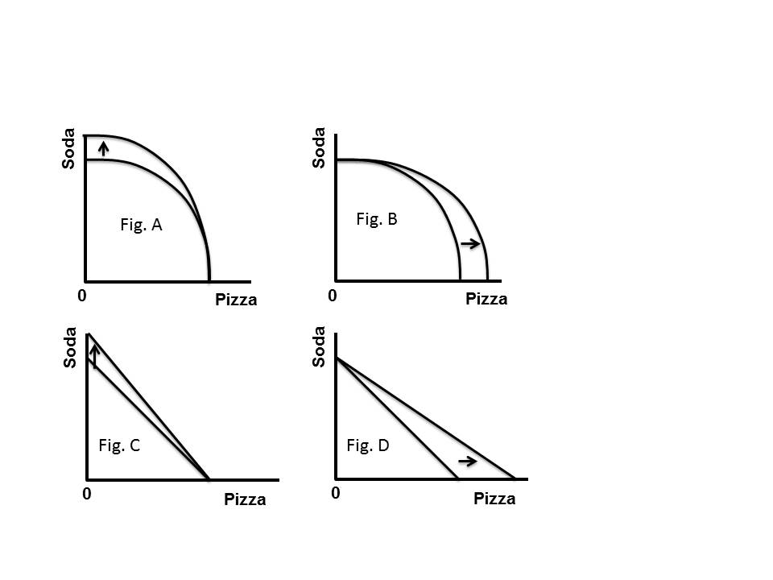

* 1. Fig. A
  2. Fig. B
  3. Fig. C
  4. Fig. D

Answer: A

Learning Objective: 01-02

Topic: Economic Growth

Blooms: Apply

AACSB: Knowledge Application

Difficulty: 2 Medium

1. Referring to the Production Possibilities Frontiers in Figure 1.10 A, B, C, and D, which depicts specialized growth in soda when there is constant opportunity cost.

Figure 1.10 

* 1. Fig. A
  2. Fig. B
  3. Fig. C
  4. Fig. D

Answer: C

Learning Objective: 01-02

Topic: Economic Growth

Blooms: Apply

AACSB: Knowledge Application

Difficulty: 2 Medium

1. Referring to the Production Possibilities Frontiers in Figure 1.10 A, B, C, and D, which depicts specialized growth in pizza when there is increasing opportunity cost.

Figure 1.10 

* 1. Fig. A
  2. Fig. B
  3. Fig. C
  4. Fig. D

Answer: B

Learning Objective: 01-02

Topic: Economic Growth

Blooms: Apply

AACSB: Knowledge Application

Difficulty: 2 Medium

1. Referring to the Production Possibilities Frontiers in Figure 1.11 A, B, C, and D, which depicts specialized growth in pizza when there is constant opportunity cost.

Figure 1.10 

* 1. Fig. A
  2. Fig. B
  3. Fig. C
  4. Fig. D

Answer: D

Learning Objective: 01-02

Topic: Economic Growth

Blooms: Apply

AACSB: Knowledge Application

Difficulty: 2 Medium

1. Referring to the Production Possibilities Frontiers in Figure 1.11 A and B, which depicts generalized growth when there is increasing opportunity cost.

Figure 1.11 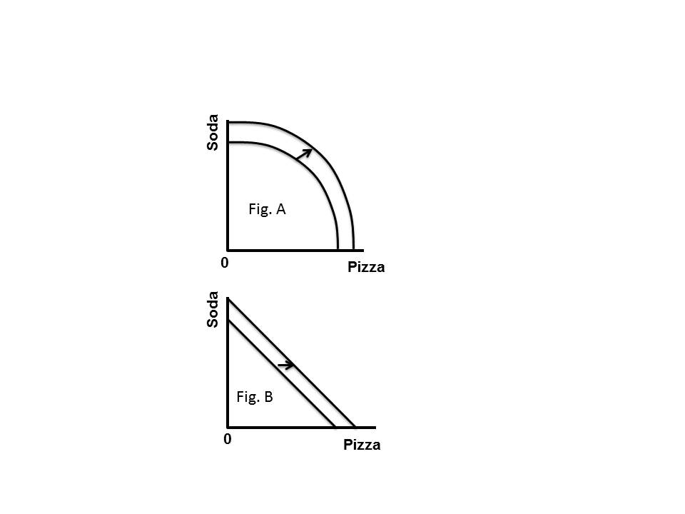

* 1. Fig. A
  2. Fig. B
  3. Either A or B is correct
  4. Neither A nor B are correct

Answer: A

Learning Objective: 01-02

Topic: Economic Growth

Blooms: Apply

AACSB: Knowledge Application

Difficulty: 2 Medium

1. Referring to the Production Possibilities Frontiers in Figure 1.11 A and B which depicts generalized growth when there is constant opportunity cost.

Figure 1.11 

* 1. Fig. A
  2. Fig. B
  3. Either Fig. A or B is correct
  4. Neither Fig. A nor B are correct

Answer: B

Learning Objective: 01-02

Topic: Economic Growth

Blooms: Apply

AACSB: Knowledge Application

Difficulty: 2 Medium

1. Referring to the Production Possibilities Frontiers in Figure 1.11 A and B, which depicts generalized growth

Figure 1.11 

* 1. Fig. A
  2. Fig. B
  3. Either Fig. A or B is correct
  4. Neither Fig. A nor B are correct

Answer: C

Learning Objective: 01-02

Topic: Economic Growth

Blooms: Apply

AACSB: Knowledge Application

Difficulty: 2 Medium

1. Referring to the Production Possibilities Frontiers in Figure 1.11 A and B, which depicts specialized growth

Figure 1.11 

* 1. Fig. A
  2. Fig. B
  3. Either Fig. A or B is correct
  4. Neither Fig. A nor B are correct

Answer: D

Learning Objective: 01-02

Topic: Economic Growth

Blooms: Apply

AACSB: Knowledge Application

Difficulty: 2 Medium